Student Device Repair Request
Here are directions parents can follow to request repair for student device.
- Parent type in URL: https://bcpsone.bcps.org/support/.
- The page will look like this and parent want to click on Parents and students- Click here to request support.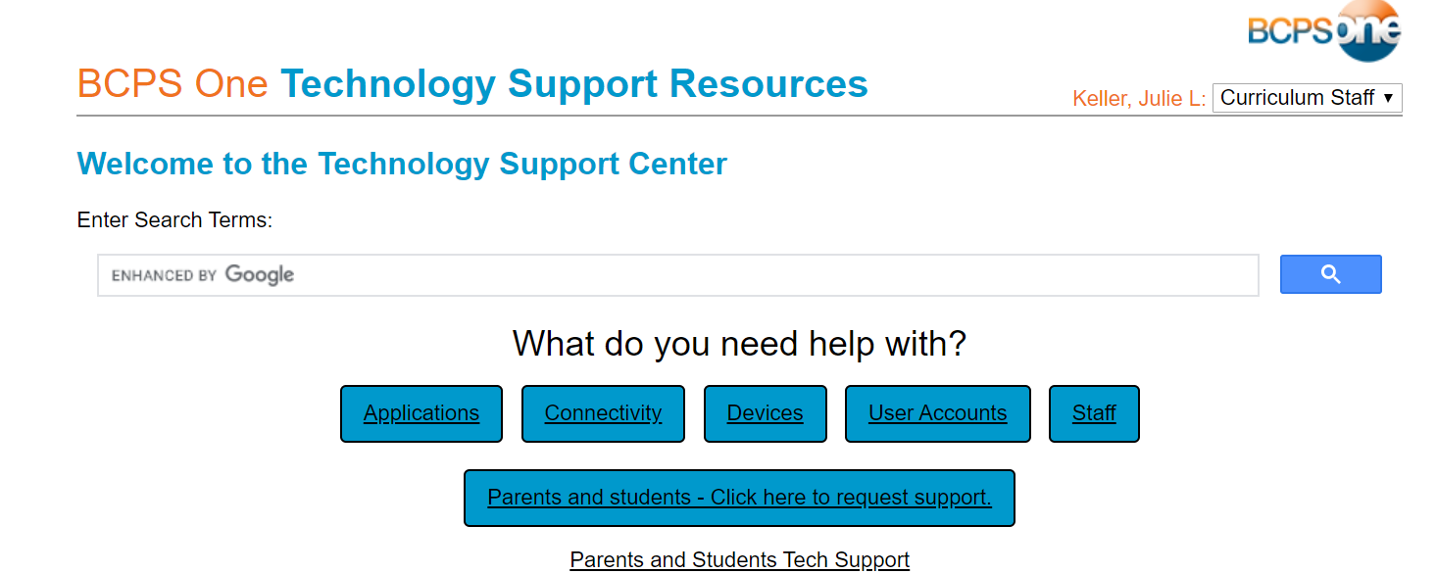
- Parent will need to complete the form and submit.
